News Mood – Observations and Analysis

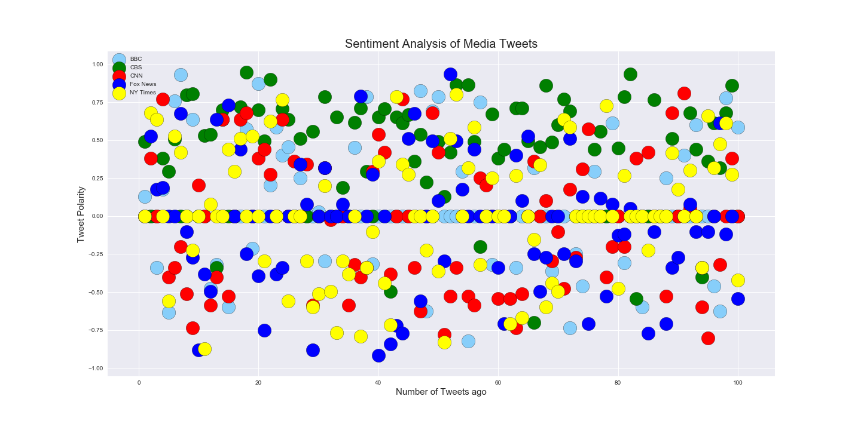

1. When you look at the scatter plot, it is hard to justify the overall analysis pattern because the data is all over the place. You will see all the bubbles for BBC, CBS, SNN, Fox News and NY Times scattered *almost evenly* for the last 100 tweets to be in the composite scale of -1 to +1
2. You will see a lot of bubbles have a polarity of 0 (zero) or close to zero – CNN and Fox News dominating mainly.
3. As the data over here is not giving us much conclusion, we go the next chart, in the next page.

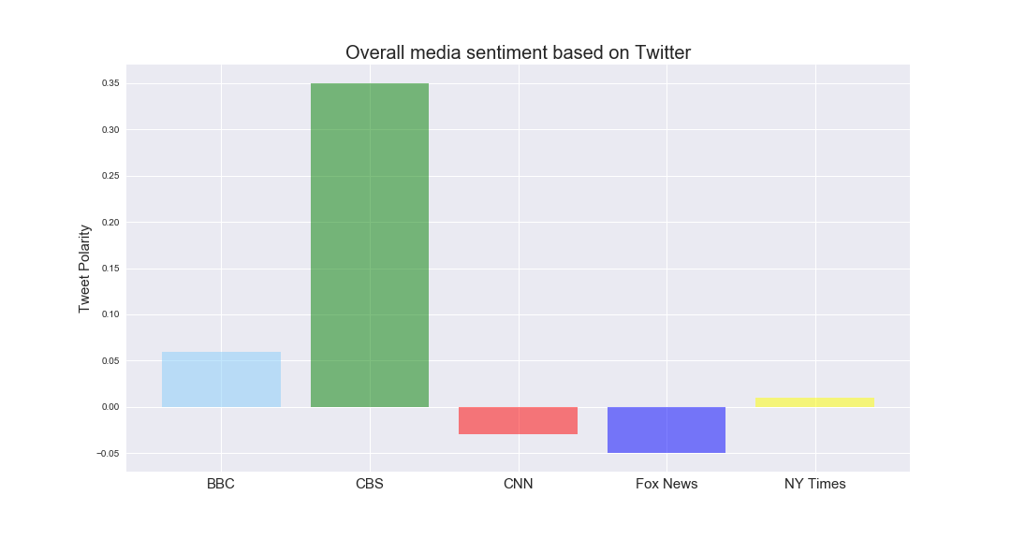

1. Data here is more meaningful as we have taken an average of 100 tweets
2. You will see that BBC, CBS and to a certain small extent, NY Times have shown positive sentiments for their tweets, whereas CNN and Fox News have been negative.
3. With news, and that too for last 100 tweets, it is very difficult to analyze what is ‘really going on’. For example, some news outlets will be very happy about a certain policy change, certain trade regulations with foreign countries (like China), certain spikes or downfalls in stock markets etc., whereas the other news outlets may talk about the exact same items in a negative manner.
4. A more meaningful representation will be that if we continue to collect let’s say 100-500 tweets per day, aggregate them per month, and then create a ‘monthly average’ sentiment analyzer. We then further aggregate and average it out on a ‘quarterly basis’. This data will be more meaningful as it will show us on an average how positive, negative or neutral our news outlets tweets are.